

**Exploring WebGL**

Key words: javascript, webGL, threejs, node.js, stl

**Estimated Time**

One hour for the basic functionality if you are have worked with these tools. Less than 20 lines of code in index.html are needed to complete the basic functionality.

**Goal**

In this open-ended problem, you will be exploring webGL capabilities. Feel free to read any material on the topic and copy paste any example code from the internet. The objective is to test your abilities to quickly get a web ui up and running. While doing so, keep in mind that the code should be kept clean, short, and readable. When you find a long piece of source code, make sure to only take the useful bits. If you are unfamiliar with the tools and got stuck, do not panic. Just explain to us where and why you got stuck in the submission.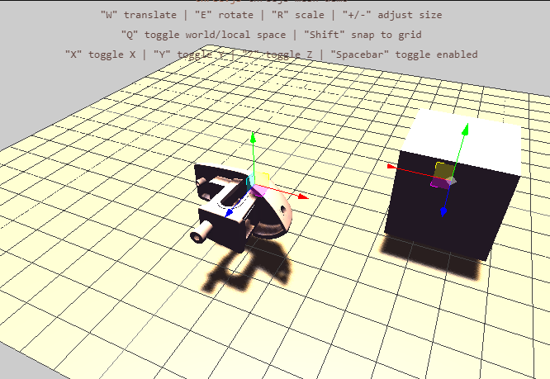

Figure. 1 The threejs demo for viewing 3D mesh files stored in .stl format.

**Getting started**

Follow Readme.md.

**Basic Functionality**

* Make a button that asks the user to select a local stl file. Some example stl files are provided in the meshes folder.
* Load the stl and display it in the web ui.
* Code needs to run on Chrome and Windows 10 (I know).

**Explore**

* Clean up or fix bugs in the starter code. Explain what you fixed and how you found out the bug.
* Put the mesh on the lower left corner of the floor when loaded. Also snap the model so that it sits right above the floor.
* Convert the project to React and/or Typescript.
* Maintain a list of multiple meshes loaded.
* Add a button to save the file names of the meshes to a .txt file.
  + Also save their positions and rotations
* Add a way to select and duplicate a mesh
* Incorporate other cool demos from the threejs examples
  + Live demos: <https://threejs.org/examples/>
  + Source code: <https://github.com/mrdoob/three.js/tree/dev/examples>.
* Convert the project to a standalone exe using Electron or other tools.

**Deliverables**

* index.html or source code for React project.
* Do not include the meshes that we gave you or files automatically generated by node or React. Include instructions for how to generate the project instead.
* A document in a common format such as .txt, doc, pdf explaining highlights of your work and cool screenshots.